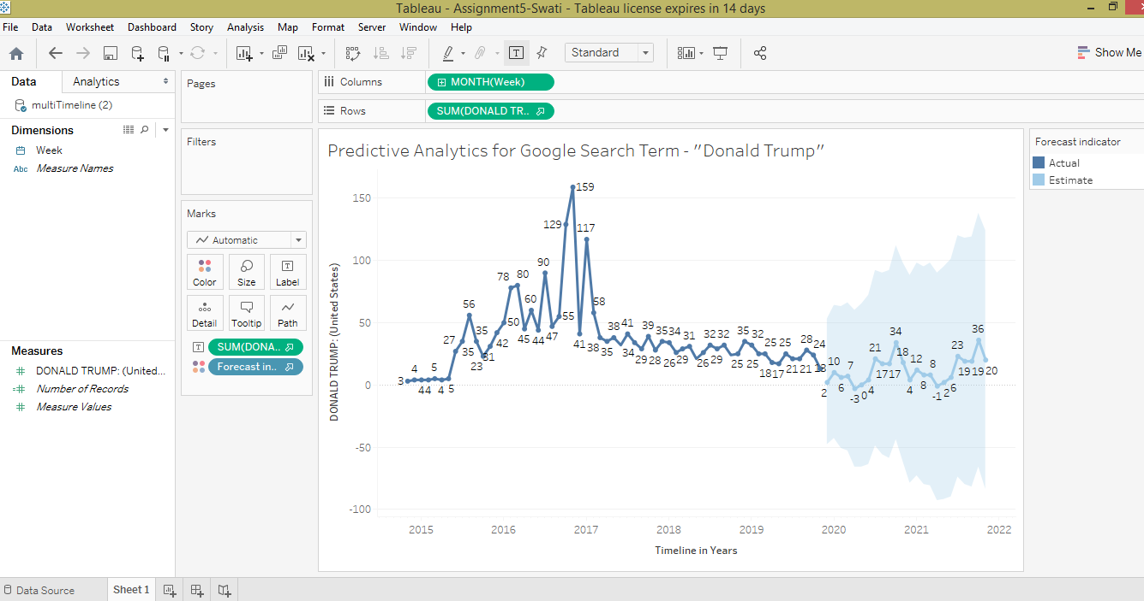

**Explanation of the above Forecasted Results**

The above plot shows how and when “Donald Trump” (referred to as the ‘President’ hereafter) became a popular term. People started to google the President’s name in June 2015 which is when he formally launched his presidential campaign. This popularity grew as the election date neared and peaked at the end of 2016 when he was announced as the next President of the United States. The term dwindled suddenly as people already begun to know him.

The forecast algorithm also largely reflects this drop in popularity as per the trend that has followed in the last three years. It does not take so much of the peak (November 2016) into account maybe because the algorithm treats it like an outlier. The forecast also shows that the popularity may drop completely (<1) as was the case in the past (prior to June 2015).